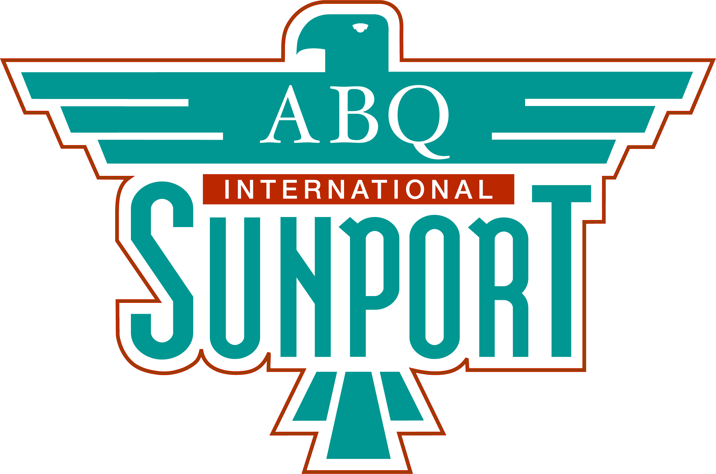

Airport Advisory Board Meeting

Meeting Minutes
Location: Aviation Department Conference Room, 3rd Floor, Administrative Offices
Date: March 19, 2026
Time: 9:00 am – 10:00 am
 | Attendees
Board Members | Aviation Department | Other
Marc Limmany, Chair.  Nalleli Reyes Garcia, Vice Chair (absent)  Fred DeGuio  Dayan Hochman Vigil  (Zoom)  Jon Word  Daniel Wald  Sara Collins  George W. Skarbek- Borowski | Lisa Abeyta  Gary Gilliard  Brian Boyd  Yvette Garcia  Jeanette Whittaker  Keith Seamars  Myrna Marquez  Dan Jiron  Commander Rivera  Jonathan Small  Patrick Frias | Scott Sikel (HDR)  Brett Shank  Cooper Metts  Matt Olguin (Cutter)  Tim Gorman (BODE)
 | Minutes

- Call to Order and Roll Call
Chair Limmany called the meeting to order at 9:03 a.m. Chair confirmed that a quorum was present.

- Approval of Agenda or Amendments and Additions
Chair Limmany requested a motion to approve the agenda for the March 19, 2026, meeting. Member Word moved, and Member DeGuio seconded. The motion passed.

- Approval of Minutes
Chair Limmany requested a motion to approve the minutes from the February 19, 2026, meeting. Member Word made the motion, and Member DeGuino seconded it. The motion was approved.

- Director’s Report (Lisa Abeyta, Acting Deputy Director)
- Announcements
  - Lisa Abeyta, Acting Deputy Director, is filling in for Acting Director Manny Manriquez, who is on vacation.
  - Deputy Abeyta welcomed a new member to the Sunport team: Kelly Ward, our Senior Manager for Real Estate & Commercial Development.
  - Myrna Marquez, Associate Deputy Director, Design and Construction Management, provides a brief project update to the following:
    - Inline Baggage project, contractor to hand over the design to get started on this project.
    - Fire Suppression project, working with a design professional to get all federal regulations in place to move forward.

- Department Updates

- Brian Boyd, Deputy Director of Airfield Operations, reports on air traffic and Sunport updates.
- Total operations at DEII for January were 3890, 6.9% below the 5-year rolling average for the month.
- DEII Operations is 54180, 3.5% below the 5-year rolling average.

- DEII Tower Upgrades underway.
- DEII Terminal Design on Hold
- Starting next phase of Vertiport Planning.
- Run the Runway scheduled for 1st Saturday in September.
- Total Operations at Sunport for January was 11134, which is flat the 5-year rolling average for the month.
- ABQ Sunport Runway 3/21 Lighting Project has started.
- Runway 3/21 will be renamed to Runway 4/22 because of delays on the FAA side; the renaming process won't be completed for about 18 months.
- The UAS working group has been formed between Sunport, NMDOT-AVE, FAA, and DoW.
- Terminal Perimeter Concrete Project underway.
- Sunport awarded an FAA beyond eIPP AAM Project Site.

- Gary Gilliard, Deputy Director of Landside, reports on business development.
- Sunport happenings: Concessions Program Sales December 2025. Sales are up 0.3%. Food/Beverages sales are up 9.1%.
- New Concession Units set to open: Laguna Burger, Famous Franks Chicken & Waffles. Grand opening of Theobroma Chocolate on April 1st in A Concourse.
- Jonathan Small, Customer Service Manager, reports on customer experience: there was a call for sculptors in the arrival area across 5 locations. That opportunity closed a few weeks ago, and the response was fantastic. New History Exhibit 2 years in the making. More to come. Route 66 monument sculpture has been installed in the exit corridor. A lot of engagement and excitement have been generated.
- Dan Jiron, the Associate Director of Strategic Planning, provides updates on Air Service. Seat capacity has decreased by 2.3% compared to last year, but passenger traffic continues to grow. Year-to-date enplanements and deplanements are down 1.9% from the same period last year. Since March 1, Contour Airlines has been operating, with passenger numbers increasing. In the upcoming meeting, our team will provide more details on passenger counts. Delta Airlines offers Saturday service to Seattle. Sun County Airlines added 8 flights for the Balloon Fiesta. Southwest Airlines has resumed flights to Kansas City for October. Aviation has organized a food drive for TSA, and the response and donations have been excellent.
- Member DeGuio has reported on air service updates for Spring/summer 2026. (Please see attachment.)

- Subcommittee Updates
- Chair Limmany has revised the Subcommittee chart to include the three subcommittees and leadership. Members Collins and W. Skarbek-Borowski gave an update on the Community and Engagement & Customer Experience subcommittee.
- The new onboarding manual for the new Ambassador program is in progress.
- Member Collins and Tracy Perea have been working on improving employee engagement and finding better ways to recognize employees for their hard work.
- Old Business
  - No updates.

- New Business
  - Member Wald attended the New Mexico Delegation alongside the State and City Economic Development teams. He spoke extensively about the Sunport, highlighting its impressive amenities and the iconic floors of the Sunport.
  - Member Collins participated in a Home Wise discussion on housing affordability. During the event, a gentleman attendee mentioned that he had never been to New Mexico but arrived at the Sunport and saw the stunning wall of UNM crest books, which made him feel at home.

- Board Questions/Input:

- Member Wald requested that Associate Deputy Marquez give a clearer explanation of the In-Line baggage system. Deputy Boyd explained that, currently, baggage passes through high security, with about 9 scanning machines. The new process will require only three high-security scans and will need less maintenance due to the smaller, compacted machines. Sunport will also have more reinstatement fees, generating additional revenue.
- Member Collins inquired if we possess the GMP plans for the Observation Deck. The Associate Deputy confirmed that we do.
- Member W. Skarbek-Borowski asked whether Ten Tanker is set to retire the MD11, but FedEx is planning to keep them. Deputy Boyd said Ten Tanker has not yet had discussions with Sunport, and for now, we shall wait to hear more about further plans.
- Chair, Limmany asked if we will be having an Airshow this year. Deputy Boyd stated not this year.

- Next Meeting Date: Thursday, April 16, 2026, at ABQ Sunport Aviation Large Conference Room

- Chair Limmany requested a motion to adjourn the meeting. Member Collins moved, and Member Sharbek-Borowski seconded the motion. The motion passed
Meeting Adjourned at 10:00 a.m.

